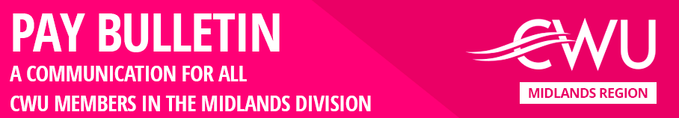

No 4 – 21st July 2022

**A Massive 97.6% YES Vote But Now Royal Mail Pleads Poverty**

It was inevitable. The moment that the CWU announced a 97.6% YES vote for strike action, the greatest ever YES vote by any Union, ever, Royal Mail announced it had no money for a decent pay rise.

The Royal Mail Board now conveniently claims that the company is losing money. Judge that statement against these facts:

**CWU members delivered a £1 billion turnaround on the Boards projected finances,** but there is no money for a decent pay rise for us.

**In April 2022, Royal Mail announced £758 million profits**, but there is no money for a decent pay rise for us.

**In January 2022, the RMG Board gave away £200 million to shareholders via a special dividend, paid over and above the standard dividend,** but there is no money for a decent pay rise for us.

**In January 2022, the RMG Board wasted £200 million on a share buy-back scheme,** but there is no money for a decent pay rise for us.

**At this week’s Annual General Meeting the RMG Board proposed a resolution to give away a further £167 million in dividend payments,** but there is no money for a decent pay rise for us.

**The RMG Board awarded the Chief Executive Officer a bonus of £140,000 for achieving 17% of his targets,** but there is no money for a decent pay rise for us.

**The Board will find the money to pay the inevitable Ofcom fine resulting from their mismanagement of the company and the USO and quality of service failures,** but there is no money for a decent pay rise for us.

**The Board found the money needed to buy off the managers dispute,** but there is no money for a decent pay rise for us.

Don’t buy into the Royal Mail narrative that they are broke. The above **facts** prove this dispute is about not about the affordability of a decent pay rise - it’s about choices. **Royal Mail is choosing to prioritise everyone else above you.**

Well now the Royal Mail Board, has another choice to make; ignore the overwhelming voice of their workforce, democratically expressed through a secret ballot and face strike action, or respond positively to the ballot result, get back into negotiations with the CWU and agree a pay rise that you deserve and need.

**Choose wisely Royal Mail.**

Paul, Simon & Steve

Midlands Divisional Reps

p.s. We will shortly be producing a further *Members Bulletin* on the 2nd industrial action ballot we are having to run on RMG’s plans to rip up many of our hard won terms and conditions